**HOME INVENTORY CHECKLIST**

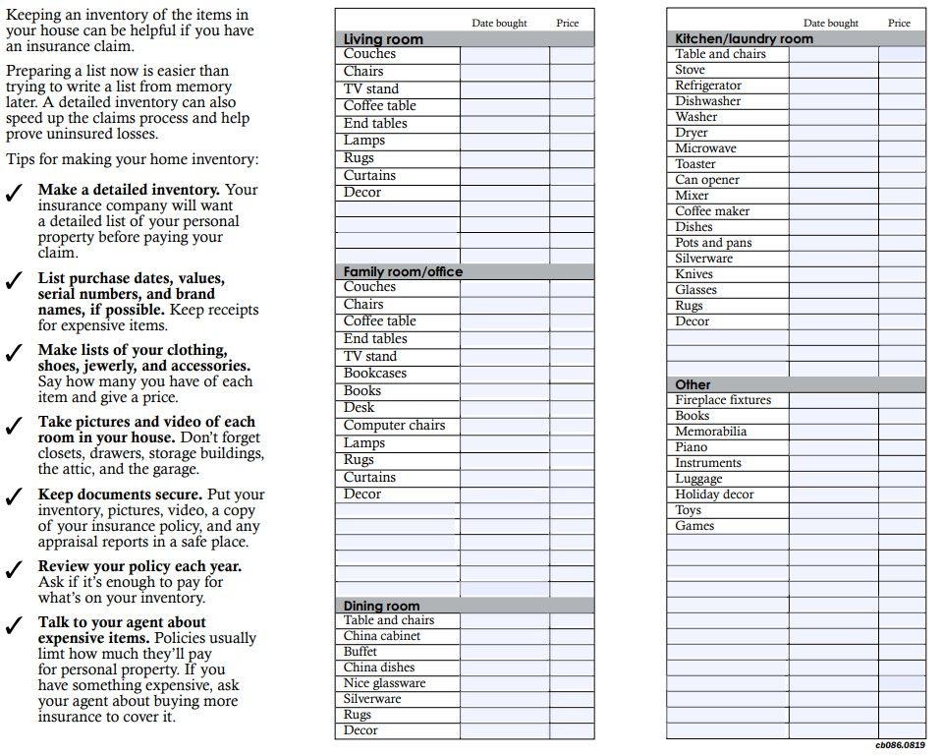

| 1

rvices. All rights reserved

© 2014-2017 USI Insurance Se

**HOME INVENTORY CHECKLIST**

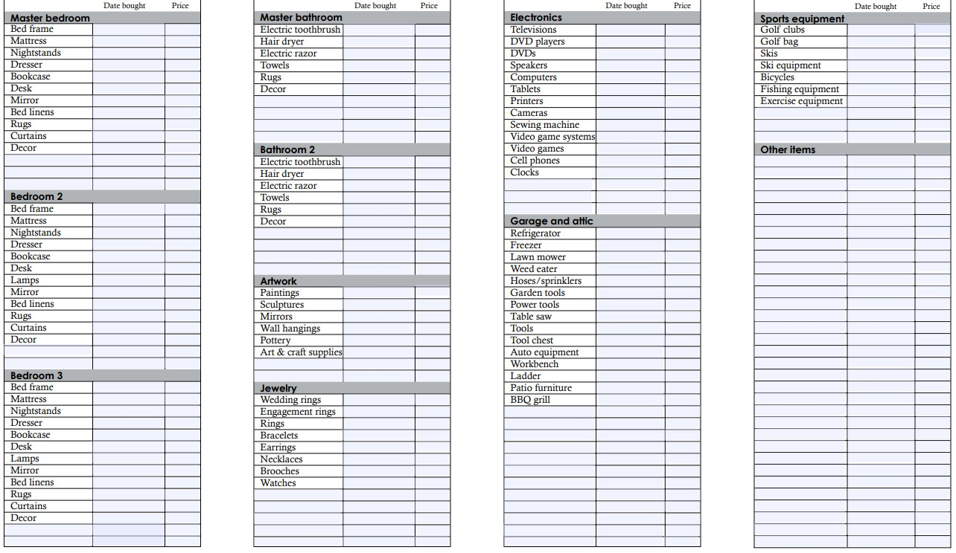

| 2

© 2014-2017 USI Insurance Services. All rights reserved